# Install Telegram Messenger on your smartphone.

# Click on Search icon and Type @BlueDiscBot

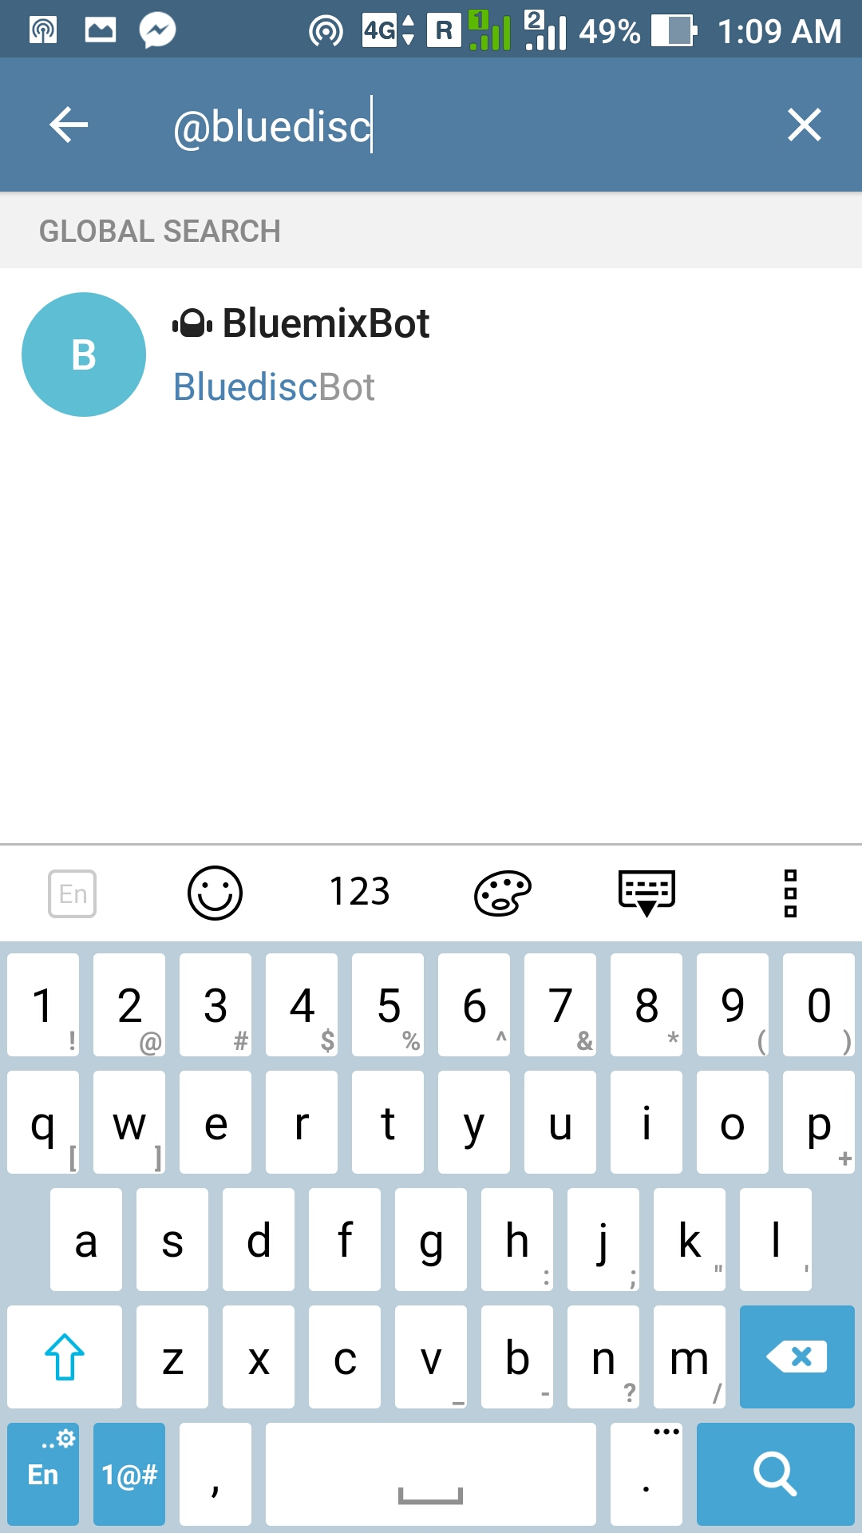

# Click on START

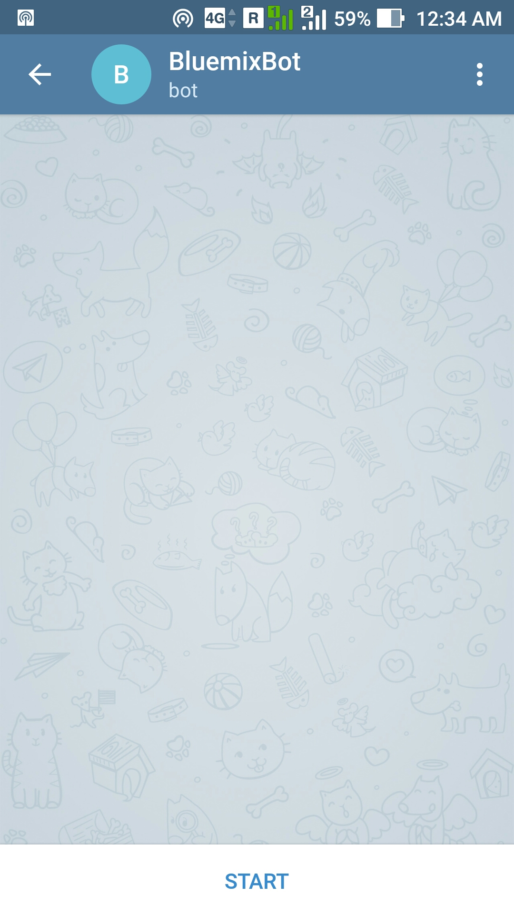

# See Authorization steps

